Table of Contents

Overview 2

Enhancements 2

CloudEndure Migration Factory (CEMF) Account Entry 2

Limitation 2

How to Set the Environment Variables 2

How to Verify if the Environment Variable Exists 3

Linux and Windows Account Entry 3

How It Works 4

Dependencies 4

Limitations 4

CloudEndure API Token Enahcement 5

How It Works 5

Dependencies 5

Limitations 5

Using the script in CEMF Workshop Environment 6

Using SSH Private Key in connecting to Linux Machine 6

Recommended Future Enhancements 7

Minimize entry of CloudEndure API Keys. 7

Safely Store Account Information 7

Appendix – Script Dependencies 8

# Overview

Enhance existing CEMF migration script to minimize user input of CloudEndure Migration Factory account and respective server accounts on both Linux and Windows servers. Manually inputting the account takes time and prone to user error.

This enhancements will minimize manual input of CEMF account and server accounts to improve efficiency of the users.

# Enhancements

## CloudEndure Migration Factory (CEMF) Account Entry

Out of 17 CEMF scripts 16 of these scripts requires you to enter the account every time you run it. You run this 16 scripts in every wave migration. If you have 10 waves in the migration you will input the account at least 160 times assuming you enter it all correctly. Minimizing the manual entry of the scripts also minimizes manual entry errors, speed up the migration, and will improve efficiency of the user.

All the scripts that requires CEMF account are enhanced by allowing user to set CEMF username and password in environment variable. If the script detect that there is account information in the environment variable, it will prompt the user whether to use the account or enter the account manually.

If the environment variables are not set it will behave to its default behavior which is to ask the account.

You must set this environment variable before you execute the script. You don’t need to set it again when you execute another script if you are using the same command console or if you did not open another command console to execute the script. See How to Verify if the Environment Variable Exists.

In the image blow, it shows the question being ask by the script once CEMF account information is detected. If the user replied *Y*, it will proceed using the predefined account. It will also notify the user that the predefined account is used.

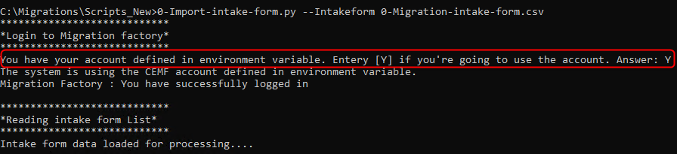

### Limitation

The environment variable only exist within the session of the command console. If you open a new command console or you reopen a console, you need to enter the environment variables again.

### How to Set the Environment Variables

Use *SET* command of the windows command console to set the environment variable. For CEMF account we have to environment variable to set.

* CEMF_USERNAME. Your CloudEndure Migration Factory username.
* CEMF_PASSWORD. Your CloudEndure Migration Factory password.

Use *SET* command to set these environment variables with your CEMF account follow this script:

SET CEMF_USERNAME=<your CEMF username>

SET CEMF_PASSWORD=<your CEMF password>

Example:

SET CEMF_USERNAME=rod@mydomain.com

SET CEMF_PASSWORD=Abc123def*

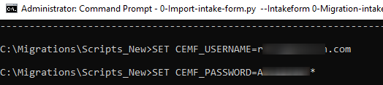

### How to Verify if the Environment Variable Exists

To verify if you have existing environment variable set, use *ECHO* command.

ECHO %<environment variable>%

Example:

To display the CEMF username or password, use this script.

ECHO %CEMF_USERNAME%

ECHO %CEMF_PASSWORD%

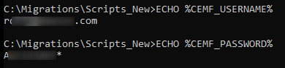

## Linux and Windows Account Entry

Out of 17 CEMF scripts there are 6 scripts that requires you to input server account information to check the prerequisites, install agents, copy file, shutdown instances, and verify server connection. If you have 20 servers to migrate in a wave, you need to input the accounts 20 times in single CEMF script which is a total of 120 manual entry for the wave migration. If you have 10 waves in the migration plan you will input the account at least 1200 times assuming you input it all correctly.

Other improvement brought by this enhancement, it gives option to the user to enter different account in a server that previous script does not allow.

To enhance this feature we allow the script to store the account information and allow the user to decide whether to:

* Enter the account manually
* Use the previously entered account
* Use the previously entered account to all remaining servers.

Linux and windows servers account are stored separately.

### How It Works

The script store the account information automatically every time the user enter the account. The data is stored in *cemf_settings.json* file. On the succeeding request and account information is available, the script will ask the user to:

* **Enter the account manually (Default)**. If the user chooses this option, it will allow the user to enter the account. This account will be saved that way it can be used in the next request.
* **Use the previously entered account (Choose: Y)**. If the user chooses this option, it will allow the user to use the previously entered account to save time and minimize error in manually inputting the account. The script will ask again before processing the next server.
* 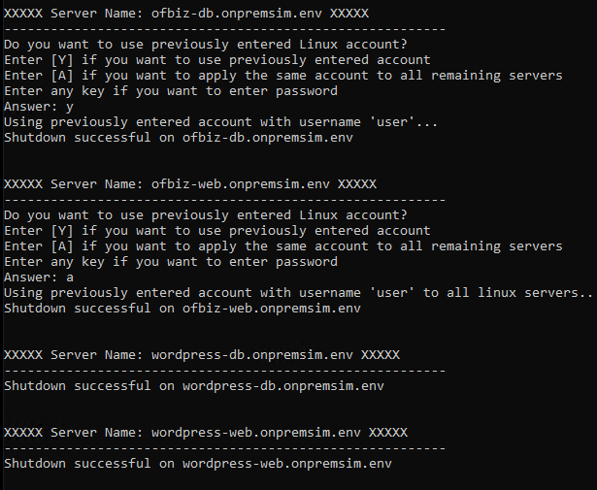**Use the previously entered account to all remaining servers (Choose: A)**. If the user chooses this option, it will allow the user to use the same server for all succeeding servers in the script.

If the script did not detect account information or it’s your first time to use the script, it will use the default behavior.

In the screenshots, you can see how the system behave when **Y** (Using Previously entered account) is selected and **A** (Apply the same account to all remaining servers).

### Dependencies

A new script *cemf_helper.py* is added. This is contains custom helper functions added to simplify the code change and isolate changes from the core codebase.

This also centralizes the enhancement changes in single file for readability and maintainability.

### Limitations

Currently the data is stored in *cemf_settings.json* file not encrypted. This file is auto-generated by the script once account is inputted.

Sample Data:

{

"linuxUsername": "user",

"linuxPassword": "password",

"linuxHas_key": "N"

...

...

}

Make sure to manually delete this file after using the scripts. This feature enhancements is added in the Recommended Future Enhancements.

## CloudEndure API Token Enahcement

CloudEndure API Token is a key that is use to allows Migration Factory to communicate with CloudEndure through API. There are 5 CEMF scripts that requires you to manually enter the 64 digit CloudEndure API token that is generated by *0-CEProjects.py* script and users will manually copy it from the console.

### How It Works

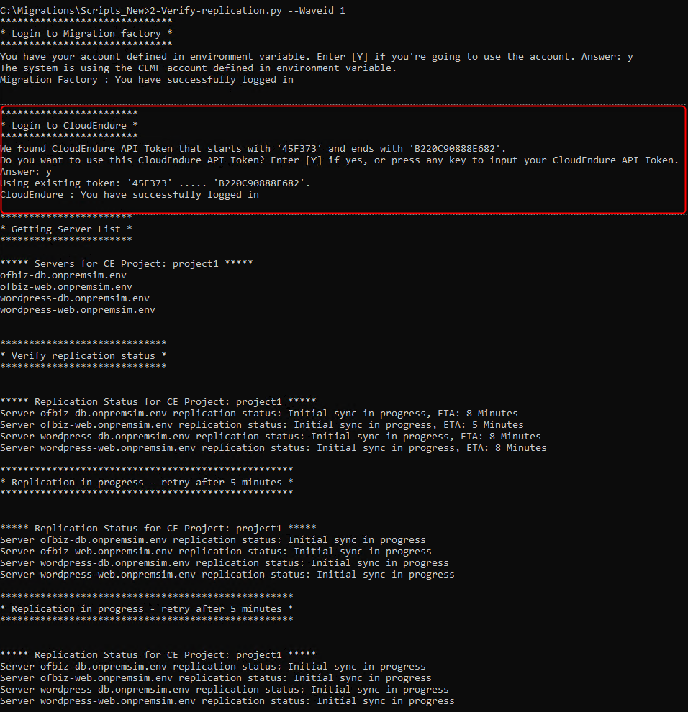When CEMF creates CloudEndure project (*0-CEProjects.py*), it creates CloudEndure project and returns the CloudEndure API token. This token is automatically stored to be used by 5 CEMF script that is dependent to CloudEndure API Token.

When CloudEndure API token is detected by the script it will prompt the user whether to use it or to manually input the CloudEndure API token. If the user choose to use the previously saved token, it will automatically use by the script to communicate with CloudEndure API else the user is required to manually input the 64 character token.

### Dependencies

A new script *cemf_helper.py* is added. This is contains custom helper functions added to simplify the code change and isolate changes from the core codebase.

This also centralizes the enhancement changes in single file for readability and maintainability.

### Limitations

Currently the CloudEndure API token is stored in *cemf_settings.json* file and not encrypted. This file is auto-generated by the script once account is inputted.

Sample Data:

{

"CEApiKey": "user",

...

...

}

## Using the script in CEMF Workshop Environment

If you want to use this script in workshop environment, you need to update the *0-Import-intake-form.py* script to exclude the validation of *aws_account* since this column is not supported yet by the *0-Migration-intake-form.csv* in the workshop environment.

You can get the workshop version of *0-Import-intake-form.py* in workshop folder of the script.

## Using SSH Private Key in connecting to Linux Machine

Verified that CEMF script supports using SSH Private Key. I confirmed and tested that is already supported by the existing CEMF script.

All you have to do:

* Answer ***Y*** when prompted “*If you use a private key to login, press [Y] or if use password press [N]*”. 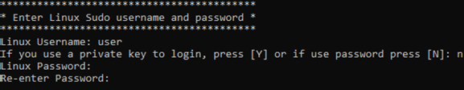
* Enter the *path* where the SSH private key file is located in your local machine.

The SSH private key (*.pem) is downloaded when you create EC2 key pair.

Testing Output:

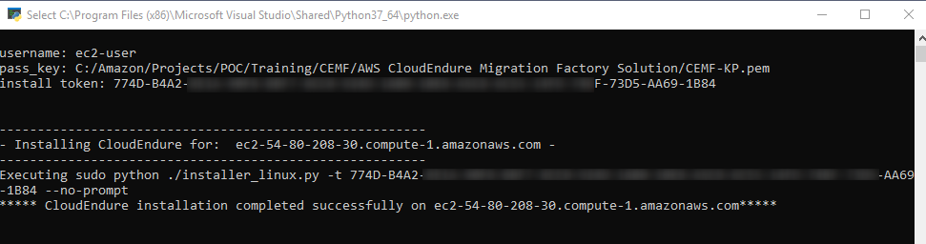

# Recommended Future Enhancements

## Safely Store Account Information

Use [AWS Secret Manager](https://aws.amazon.com/secrets-manager/) to store the data securely to avoid security issues when settings file is not deleted after the migration.

# History

|  |  |  |
| --- | --- | --- |
| Date | Author | Comments |
| 6/29/2020 | Rod | Initial Draft |
| 7/6/2020 | Rod | CEMF Login, Linux/Windows login enhancements |
| 7/9/2020 | Rod | Added CloudEndure API Token Enahcnement and Using SSH Key in connecting to Linux server |
| 7/13/2020 | Rod | Added history and updates |
|  |  |  |

# Updates

* Version 0.1 – Integrated CEMF Login and Linux/Windows Login enhancements
* Version 0.2 – Added CloudEndure API Token enhancements
* Version 0.3 – Updated install CE Agent for Linux script

# Appendix – Script Dependencies

List of CEMF scripts affected by enhancements. For documentation of these scripts you can visit [CEMF solution](https://docs.aws.amazon.com/solutions/latest/aws-cloudendure-migration-factory-solution/appendix-a.html).

|  |  |
| --- | --- |
| Script | Dependency |
| 0-AddProxy-Windows.py |  |
| 0-CEProjects.py | 0-CEProjects.csv |
|  |  |
| 0-Import-tags.py | 0-Import-tags.csv |
| 0-Import-intake-form.py | 0-Migration-intake-form.csv, FactoryEndpoints.json |
| 0-Prerequistes-checks.py | 0-Prerequistes-Windows.ps1, cemf_helper.py |
| 1-CEAgentInstall.py | 1-Install-Linux.py, 1-Install-Windows.ps1, cemf_helper.py |
| 1-FileCopy-Linux.py | post_launch scripts, cemf_helper.py |
| 1-FileCopy-Windows.py | post_launch scripts |
| 2-Verify-replication.py |  |
| 2-UserMgmt-Linux.py | cemf_helper.py |
| 2-UserMgmt-Windows.py | cemf_helper.py |
| 3-Verify-instance-status.py |  |
| 3-Terminate-test-instance.py |  |
| 4-Shutdown-all-servers.py | cemf_helper.py |
| 4-Get-instance-IP.py |  |
| 4-Verify-server-connection.py | cemf_helper.py |
| N-UpdateMigrationStatus-Hub.py |  |